YEAR 11 to 12
AS-LEVEL LAW
TRANSITION MATERIAL



INFORMATION ABOUT THE SUBJECT
WHY STUDY LAW?
Students will learn about the legal system, law making, the nature of law, criminal law, the law of tort and human rights law. Law students develop a range of skills including the application of legal rules and principles, to present an argument, analysis and evaluation of the law, legal issues and concepts.

WHY IS A LEVEL LAW IMPORTANT?
A Level Law provides an introduction to law. It allows students to learn about a fascinating subject, one which covers many aspects of life.
Students of A Level Law will:
- Develop an understanding of law and how it works.
- Learn more about society from a legal perspective both contemporary and historical.
- Learn about the interaction between law and morals, justice and society.
- Learn about different areas of law – e.g. criminal law, human rights and tort.
- Make connections with business, economics, history, politics and technology.
- Develop academic skills, including analysis and evaluation.
- Be able to make an informed decision about future careers.
HAVE YOU EVER WONDERED . . ?
- Why do we need laws?
- How are laws made?
- How do judges make decisions?
- What are the different types of court and how do they operate?
- How do people become solicitors or barristers?
DO YOU WANT TO KNOW ABOUT:
- Criminal offences such as murder and theft?
- Negligence and how you can sue someone else?
- Your rights?

ARE YOU. . .?
- Are you interested in a becoming a solicitor, barrister or legal executive?
- Are you interested in a career in business?
- Are you interested in a career in politics or government?
- Are you studying business or economics?
- Are you studying humanities or social science subjects?
- Are you interested in debating controversial issues?

HOW WILL YOU BE ASSESSED?
- The exam board we are with is OCR.
- A Level Law is assessed by written examinations.
- The A Level qualification consist of three exam papers, each 2 hours long with a total for each paper of 80 marks and each worth 33 1/3% of the total marks.
- There is a variety of exam questions including:
  - Factual recall AO1 questions
  - Legal application scenario AO2 questions
  - Critical evaluation essay AO3 questions

SO WHY DO IT?
- A Level Law provides a fascinating insight into so many different disciplines. There are many benefits of studying A Level Law. It links all aspects of society.
- It helps students develop a range of transferable skills:
analytical skills, attention to detail, logical thinking, research skills, essay writing skills and the ability to produce a balanced argument.
- The course is engaging and encourages the learner to experience the ‘law in action’ and is relevant to everyday life through case analysis and scenario application
- The study of law links with other areas of study e.g. business, economics, history, politics and sociology.

THOUGHT PROVOKING QUESTIONS
- How is the law changing?
- What is the impact of laws on society norms?
- What is the relationship between law and morals?
- Does the law provide justice?

WHAT’S INCLUDED?
A Level Law covers a wide range of subject content including:
- The legal system
- Law making
- Criminal law
- The law of tort
- The nature of law and
- A choice of human rights law or the law of contract. At Haydon, we have opted for Human Rights which is a very dynamic and relevant aspect of the Law to everyone in day-to-day life.

WHERE CAN THE QUALIFICATION TAKE ME?
- Students wishing to continue their legal studies after A Levels can opt for a university degree or work-based apprenticeship.
- Both of these routes can lead to the qualifications required to become a solicitor, barrister or legal executive.
- As you will be gaining transferable skills beneficial to your further studies, there is a wide option with regard to university courses you can apply for with an A level in Law.
- Other popular careers include the police, teaching, social work, business and accounting.

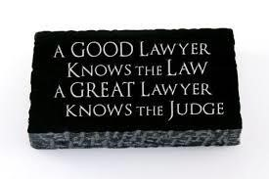

Transition work for A level Law

From KS4 GCSE to KS5 A level
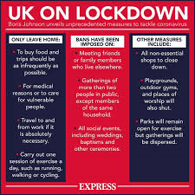
The work will be relevant and relate to real life as far as possible!

Format of transition work pack

As the A level course comprises 6 units
– H418/01 Section A Legal System - H418/01 Section B Criminal Law - H418/02 Section A Law Making - H418/02 Section B Tort
- H418/03 Section A Nature of Law
- H418/03 Section B Human Rights Law

You will be required to complete the activities from the pack based on some of the units above.

What’s the relevance for the here and now?

How do you think the government managed to make the laws on how to deal with the Covid 19 pandemic in the UK?
Where did those laws come from?
How were they made?

As you work through the pack, it will help you answer these questions.



Activity 1
Before you start learning about the law in England and Wales, it would help you to know that our laws come from 3 main sources:
- Statutory law which is mainly Acts of Parliament made by Parliament and delegated legislation made by authorised authorities like Harrow or Hillingdon Borough Council.
- Common law which is based on decisions on judicially interpreted law in cases.
- European Union law which are Regulations and decisions of the European Court of Justice.

Activity:
Research how laws/Acts of Parliament are made by Parliament.
Introduction to Parliament – what or who makes up Parliament?
https://www.youtube.com/watch?v=RAMbIz3Y2JA

To do this you will need to access the UK Parliament website.
https://learning.parliament.uk/
On this website, you can go on a virtual tour of Parliament and can explore how Parliament works.

Create a flow chart showing each stage of the legislative process of a Bill’s passage through Parliament.
https://www.youtube.com/watch?v=RAMbIz3Y2JA

Explain what is a Bill and who decides on whether the Bill becomes an Act of Parliament.
https://www.youtube.com/watch?v=EuMqjLxanyc


Activity 2

- Are there any advantages/disadvantages in the UK using this method of legislating (making laws)?
- Research at least 3 advantages and 3 disadvantages.
- Complete a table setting out the advantages and disadvantages

Check your points by using the flash cards
https://quizlet.com/91939292/advantages-and-disadvantages-of-parliamentary-law-making-flash-cards/

Activity 3
Now you need to use a skill you will have to develop in the study of A level subjects – AO3 critical evaluation.
Use the advantages and disadvantages to help you work out if the Parliamentary law-making process actually makes good laws and is an effective/efficient way to make laws.

Complete a short essay of 120 words in answer to the question below:
“The legislative process in the UK Parliament is effective in ensuring that laws made are just, effective and appropriate.”
Discuss the accuracy of this statement.

Activity 4
Are there any other ways for laws to be made aside from Parliamentary legislation?
- Yes – through delegated legislation

Activity:
Research the types of delegated legislation through watching these videos:
https://www.youtube.com/watch?v=rIWBbB2yBJA
https://www.youtube.com/watch?v=5cSv5IyLgBU
https://www.youtube.com/watch?v=qHNF_-RuF3Q
https://www.youtube.com/watch?v=0dnKBPy2xKQ
Complete a summary of each type detailing how they are made, by whom, for what purpose, giving examples.

Activity 5
Watch/read this news article:
https://news.sky.com/story/coronavirus-wales-to-open-garden-centres-and-relax-exercise-rules-from-monday-11985229
https://www.bbc.co.uk/news/uk-wales-52584690

How can the Welsh Assembly decide this for themselves before Boris Johnson had announced the plan for exiting lockdown?

Answer: Through their delegated legislative powers.

Research how this can happen.
https://senedd.wales/en/bus-home/bus-legislation/sub-leg/Pages/sub-leg.aspx - read the first paragraph

Activity 6 - Relevance to today

What about the emergency laws on the Covid19 pandemic?

https://www.gov.uk/government/publications/coronavirus-bill-what-it-will-do
http://www.legislation.gov.uk/uksi/2020/129/contents/made
https://www.gov.uk/government/news/emergency-bill-to-strengthen-coronavirus-covid-19-response-plans

- Using the links above to start you off, research how these laws were made or amended to provide regulation of protective measures on dealing with the pandemic.

SO … you now know how laws are made and in particular how the laws needed in an emergency situation like the Covid19 pandemic were made to help the UK deal with protecting its citizens.

This is about Law Making which is the unit of study for Section A of the H418/02 paper.

Activity 7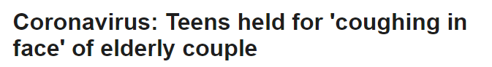

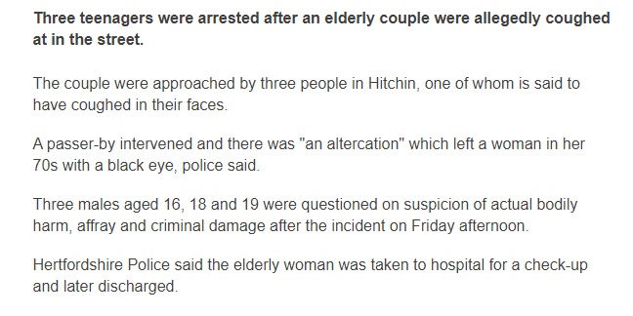

Q1. Why are the police involved in this incident?

Q2. Have the males committed any crimes? Research what are Non-fatal offences against the person.
https://www.collegelaw.co.uk/criminal-law/non_fatal_offences/index.html
https://www.lawteacher.net/lectures/criminal-law/non-fatal-offences/assault-battery/
relevant parts of https://www.cps.gov.uk/legal-guidance/offences-against-person-incorporating-charging-standard

Q3. What might the outcome be? Can you justify your answer?

Q4. If the three males were charged and had to appear in court, which courts do you think could be involved?

Use the information in the links below to find out more about the types of court, the types of cases they deal with and how they carry out their role:
There are different types and categories of cases dealt with by the English legal system.

The two main court systems we have are:
The Civil courts – dealing with litigation (one party suing another) on matters like breach of contract and disputes between two parties.

The Criminal Courts – dealing with alleged offences committed by a defendant against the criminal laws of that jurisdiction/country. It is therefore the state taking an individual/s o court for committing an offence/s.
Watch the following videos:
Criminal courts and procedure - https://www.youtube.com/watch?v=uWS_YQBeWPE

What the CPS does and what happens at court –
https://www.youtube.com/watch?v=NuW57OeTipw
https://www.youtube.com/watch?v=8rRSZFcc25E

What happens at the Magistrates Court - https://www.youtube.com/watch?v=WeNDacwO5NA

What happens at the Crown Court - https://www.youtube.com/watch?v=tZYvv_s5R-s
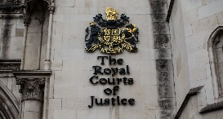
ITV documentary on the Court of Appeal - https://www.youtube.com/watch?v=i1lRB2HzXS0

Supreme Court - https://www.supremecourt.uk/

- Create a flow chart showing the hierarchy of the criminal courts and examples of the types of cases dealt with by each court.


The Old Bailey (Central Criminal Court) – the most famous Crown Court based near St Pauls.
https://www.oldbaileyonline.org/static/The-old-bailey.jsp

Q4. If the three males were convicted or pleaded Guilty, what could happen to them?

Watch the 3 videos that tell you about sentencing and how the courts go about fulfilling their role in providing justice for the Victim (and family) and the Defendant:
https://www.sentencingcouncil.org.uk/about-sentencing/

Watch the video on the types of sentences available to the court from the link below:
https://www.sentencingcouncil.org.uk/about-sentencing/types-of-sentence/

Take notes of the types of sentences and what is taken into consideration by the courts when deciding on the sentence in a particular case – you will need this to answer Q4 above.

This is about Legal System which is the unit of study for Section A of the H418/01 paper and about Criminal Law which is the unit of study for Section B of the H418/01 paper.

Activity 8
Read the following introduction on Statutory Interpretation and then complete the questions below, including the research questions.

Introduction
Acts of Parliament (also known as statutes) have a unique and important status as sources of law. Parliament is the sovereign law-making body in English law and this means that Parliament can alter the law in whatever ways it chooses. Acts of Parliament cannot be challenged by other institutions and only Parliament itself can alter what a statute says. Judges' constitutional role is that they must apply Acts of Parliament as they are written. They are not at liberty to give their own interpretation or to modify the meaning that Parliament intends. As a result, care is taken to try to ensure that the meaning of Acts of Parliament is clear. Unfortunately, it is inevitable that from time to time disputes will arise over what particular sections mean or how they should be applied. These disputes come before the courts and it is for judges to determine how such disputes are resolved.
Statutory interpretation is the name given to the process by which judges decide what particular words in statutes mean.

Why do Statutes need to be Interpreted?
• There may be a mistake in the drafting so that the words used do not mean what was intended. This happened in Fisher v Bell (1961) where the Act referred to an 'offer for sale', which in contract law had a technical meaning that differed from the everyday meaning. The result was that something could be displayed in a shop window and yet was not being offered for sale.
• Words can change in their meaning. For example, in Cheeseman v DPP (1990), the court decided that the word 'passenger' had a different meaning today to that in use in 1847 when the Act in question had been drafted.
• Circumstances can change so that the words are no longer appropriate. For instance, in Royal College of Nursing v DHSS (1981), the court had to consider the wording of the Abortion Act 1967 that a pregnancy should be terminated 'by a registered medical practitioner'. Because of advances in medical techniques, by the end of the 1970s, abortions were often carried out by nurses giving patients an injection, under the direction of a doctor.
• An Act may use a broad term instead of a limited and specific word. An example is the Dangerous Dogs Act 1991, which referred to 'any dog of the type known as the pit bull terrier'. In Brock v DPP (1993) the court had to decide what was meant by 'type'. The conclusion was that it was not the same as 'breed' so therefore it could include dogs that were not pedigree pit bulls.

TASK - QUESTIONS
- Explain what is meant by 'statutory interpretation'.

- Look at the four reasons why statutory interpretation may be needed. Which ones could have been avoided when the statute was drafted?

- Research what is meant by the Literal Rule within Statutory Interpretation and type up maximum one side of A4 notes on what you have found out.

- Research what is meant by the Golden Rule within Statutory Interpretation and type up maximum one side of A4 notes on what you have found out.

This is about Law Making which is the unit of study for Section A of the H418/02 paper

In order to perform at your highest potential in A-level Law, it is beneficial to have good literacy skills like comprehension and the ability to complete extended critical evaluation essay writing. It is also extremely helpful if students have a fairly good memory as you will need to memorise statute law and case law – the legal principles in Acts of Parliament and precedent case judgements.

VERY IMPORTANT NOTE:

All A- level Law students joining the Year 12 class will be required to sit a short baseline test based on general comprehension and extended writing. Students will also be asked questions about the Transition work completed e.g. what are the types of delegated legislation or how do Bills become Acts of Parliament (law)?

Non-essential reading list
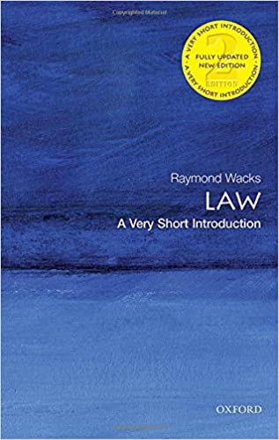
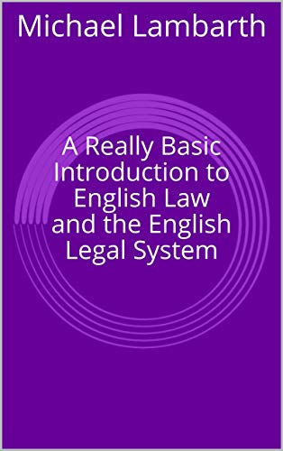

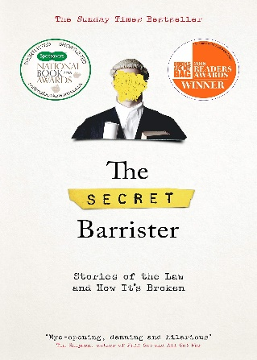
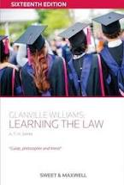
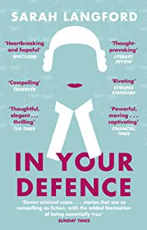
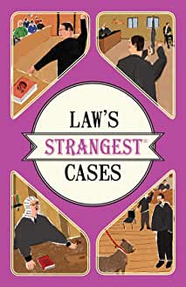

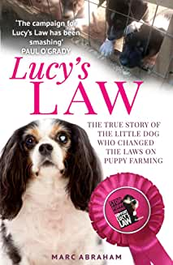
Suggested viewing:
If you have a Netflix account, there are loads of movies and TV programmes you could watch

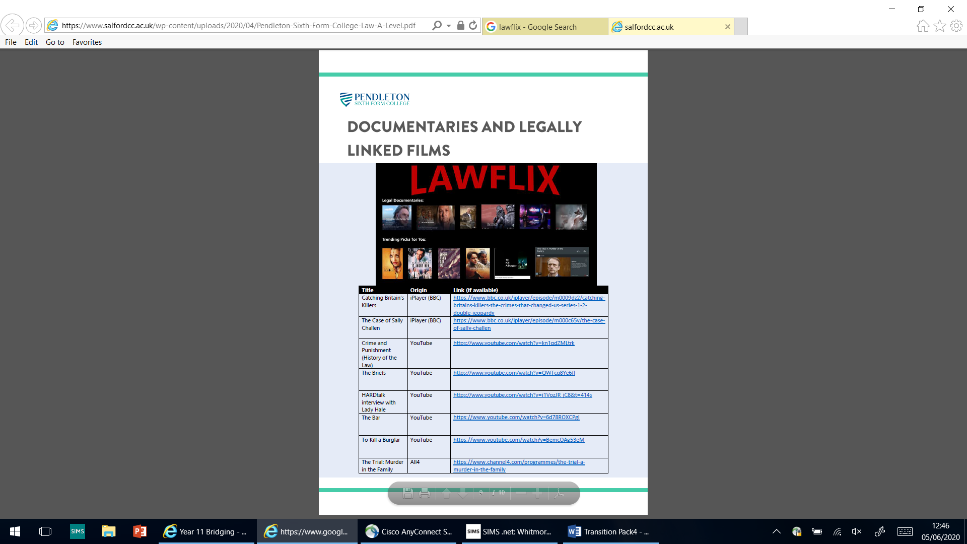
In the name of the father
10 Rillington Place
The Social Network
Twelve Angry Men
Provoked
The Whole Truth
Denial
Let Him Have It

BBC programmes

Silk
Criminal Justice
Accused
Innocence Project – a group of law students investigate cases of miscarriages of justice
The Case
Rillington Place
The Witness for the Prosecution
Black Silk
Beyond a Reasonable Doubt

Other TV programmes

The Jury
The Briefs

You could also follow well known law commentators on Twitter
@legalcheek
@joshuarozenberg
the author of 'The Secret Barrister' -@Barristersecret.

You could also keep an eye out for relevant news in the newspapers especially the Times Law Supplement.

